

Year 6 (Grade 5) Pre-test

English First Language

Instructions:

You have 60 minutes to complete this exam. Please write your name and school below and answer all of the following questions carefully.

Name:

_____________________________________________________________________

School:

_____________________________________________________________________

Examiner Only:
Score: ___/33

Section A: Grammar & Sentences (7 marks)
- Choose the grammatically correct sentence. (1 mark)
A. Each of the students have finished.
B. Each of the students has finished.
C. Each students has finished.
D. Each students have finish.
- Circle the words in the sentence that need an apostrophe. (1 mark)
The childrens dogs dont like the teachers rules.
- Which pair of verbs correctly completes the sentence below? Circle one. (1 mark)
The hungry Tyrannosaurus ____ escaped its paddock and it ____ running menacingly towards them.
A) had, were
B) have, were
C) had, was
D) having, been
- The prefixes in the sentence below are incorrect. Please rewrite the words with the correct prefix in the boxes below. (2 marks)
The sculpture was disreplacable and the museum owner was misconsolable.
- disreplacable = __________
- misconsolable = ____________
- Circle the two words in the sentences below that are antonyms of each other. (2 marks)
Although the cave looked dark, a bright flare shone from deep inside.

Section B: Vocabulary (4 marks)
- Choose the word closest in meaning to “determined.” (1 mark)
A. unsure
B. confident
C. persistent
D. placate
- Choose the most suitable word to fill in the blank: (1 mark)
The sound of thunder rumbled through the night as torrential rain battered the rooftops. Mosquitoes whirred in the air, stinging the soles of my feet and piercing my arms. The atmosphere was ______.
A. tense
B. boring
C. simple
D. ecstatic
- Choose the most suitable word to fill in the blank: (1 mark)
As the storm clouds gathered overhead, Liam paused at the edge of the cliff. He knew he had promised to help, but the path ahead looked dangerous and uncertain. After several moments of silence, he took a step back, feeling ________ about continuing alone.
A. Confident
B. Careless
C. Reluctant
D. Cheerful
- Write a synonym for the word “unlikely”. (1 mark)
________________________________________________________________________

Section C: Reading (7 marks)
Passage:
A thick fog descended. The children, who had been running joyfully through their village, stopped abruptly. A house loomed in the shadows at the end of a gravel path, like a wolf observing its dinner. There was no going back. They knew they wouldn’t be able to find their way home through the thick smog. Their only hope was to ask for help at the old manor house. The rusty iron gate creaked angrily. With a heavy heart, Ali trudged up the pathway. His white, shaking hand pressed the doorbell while his friends cowered on the pavement outside.
The ancient front door groaned as it opened. Inside the air hung with the smell of damp and decay. The masses of cobwebs that hung from every surface made it clear that this house had been abandoned for many years. The chime of a grandfather clock broke the silence momentarily before a sea of rats scurried across the floor. In the distance, a figure dressed from head to toe in black lurched forward towards its waiting prey. Ali’s friends had found their courage and were waiting next to him with intrigue.
“That’s just your shadow, caused by my torch,” Jesse explained calmly.
“But what about the rats?” enquired Ali.
The best buddies entered the house, not knowing what to expect once they’d crossed the threshold. Jesse was the first. Brave as a lion, he strode into the building while shining his torch into every corner of the room. Robyn was next, but stayed very close behind Jesse.
“Who opened the door?” asked Ali, still shivering on the step.
Finally, Florence grabbed him by the collar and pulled him into the house with the others. Once inside, the heavy oak door slammed behind them closing out the damp, foggy air while trapping them inside the putrid, dilapidated house. None of them knew where they would rather be.

- What does descended mean? (1 mark)
_________________________________________________________________________

- Identify two similes from the text. (2 marks)
- ___________________________________________________________________
- ___________________________________________________________________

- Find and copy an example of personification. (1 mark)
________________________________________________________________________
- Why did Ali have a heavy heart? (1 mark)
________________________________________________________________________
________________________________________________________________________
________________________________________________________________________
- How do we know this house is empty? Explain as fully as you can. (1 mark)
________________________________________________________________________
________________________________________________________________________
________________________________________________________________________
- Who is the most reluctant to enter the house? How do you know? (1 mark)
________________________________________________________________________
________________________________________________________________________
________________________________________________________________________

Section D: Descriptive Writing (15 marks)
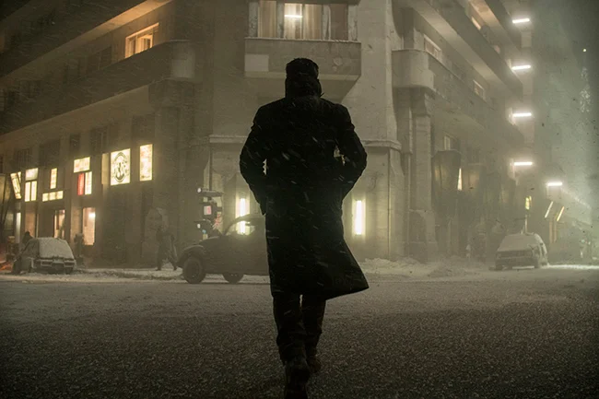
13. Write one short story based on the picture above. Use Standard English and correct punctuation throughout your writing. You will be marked on structure, content, and language used throughout the text.
_________________________________________________________________________
_________________________________________________________________________
_________________________________________________________________________
_________________________________________________________________________
_________________________________________________________________________
_________________________________________________________________________
_________________________________________________________________________
_________________________________________________________________________
_________________________________________________________________________
_________________________________________________________________________
_________________________________________________________________________
_________________________________________________________________________
_________________________________________________________________________
_________________________________________________________________________
_________________________________________________________________________
_________________________________________________________________________
_________________________________________________________________________
_________________________________________________________________________
_________________________________________________________________________
_________________________________________________________________________
_________________________________________________________________________
_________________________________________________________________________
_________________________________________________________________________
_________________________________________________________________________
_________________________________________________________________________
_________________________________________________________________________
_________________________________________________________________________
_________________________________________________________________________
_________________________________________________________________________
_________________________________________________________________________
_________________________________________________________________________
_________________________________________________________________________
_________________________________________________________________________
_________________________________________________________________________
_________________________________________________________________________
_________________________________________________________________________

